MIDDLE CLASS LEARNING AREA 2

TERM I 2026

LESSON NOTES FOR LEARNING AREA 2 (LANGUAGE DEVELOPMENT 1) FOR MIDDLE CLASS
TERM I.
WEEK I
(Observing different types of objects)
- Seeds e.g - Maize
Cow peas Beans etc.

- Shapes e.g Circle Triangles Square,etc
- Teacher game (e.g) greeting Good morning, a cat and a rat
- Rhyme
- Twinkle twinkle little star Activities
- Sorting
- Greeting
- Jumping
- Reciting
- Dancing

WEEK II
Lesson one
TOPIC: Things around the classroom.
Activity: Matching the same things in the
class
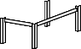

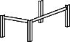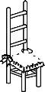

Materials to be used 
Real objects
Lesson two
TOPIC: Things around the classroom Activity: Match and draw the same pictures. Materials to be used: Real objects

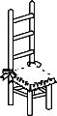

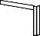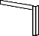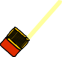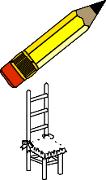

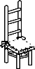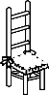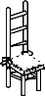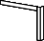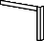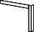Lesson three
TOPIC: Things around the class room
Activity: Colour the same picture
 | 
 | 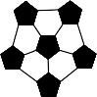

Materials to be used:Flash cards

Lesson four
TOPIC: Things around the class room.
Activity: Putting the missing part.

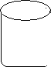

Learning materials: Real objects
Lesson five
TOPIC: Things around the classroom
Activity: Tick the odd man out

Materials to be used: Real objects, chart

WEEK III
Lesson one
TOPIC: Things at home
Activity: Colour me well


Teaching aids: Real objects
Lesson two TOPIC:Things at home Activity:Draw again
 | 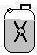
Draw Me Again | Draw Me Again | Draw Me Again

Teaching/learning aids: real objects
Lesson three
TOPICThings at home
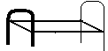Activity:Name these pictures
 | ……………………………………………….. | ………………………………………………..
 | ……………………………………………… | ………………………………………………..
bed tin cup box

Teaching /Learning aids: real objects

Lesson four
TOPIC:Things at home (common nouns)
Activity:Cross the different word tin tree tin tin
cup cat cup cup
Teaching/Learning aids: cards

LESSON FIVE
TOPIC: THINGS AT HOME
Activity: Cross the different picture
 |  |  |  | 
 |  |  | 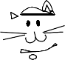 | 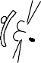 | 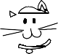 | 
 |  | Teaching/Learning aids: Charts
WEEK V
TOPIC C:THINGS AT HOME
ACTIVITY: CIRCLE THE CORRECT WORD FOR THE PICTURE.
Materials to be used: Real objects flash cards
cup pcu

itn tin

box xbo


eert tree


LESSON TWO
TOPIC: THINGS AT HOME
ACTIVITY: UNDERLINE THE CORRECT WORD FOR THE PICTURE GIVEN

table chair box
tin table tap
ball bag box
fat flower fun


Materials to be used: real objects, flash cards
LESSON THREE
TOPIC: THINGS AT HOME
ACTIVITY: TICk THE DIFFERENT WORD.
cup box√ cup cup mattin tin tin box box box bag
mug man mug mug Materials to be used: Flash cards LESSON FOUR TOPIC:THINGS AT HOME
ACTIVITY:MATCH THE SAME PICTURES AND DRAW.

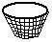

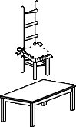


LESSON FIVE TOPIC:THINGS AT HOME.
ACTIVITY:MATCH THE SAME WORD AND WRITE IT AGAIN.
mat pot
hen cat
rat cow
cow rat
cat hen
pot mat
Materials to be used: Flash cards , chalkboard, books and pencils
WEEK SIX LESSON ONE
TOPIC:THINGS AT HOME
Activity: Matching things at home and copy words

mat mat chair cup

bed

Teaching/Learning aids: Chart/real objects
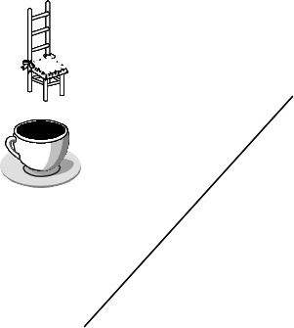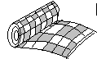

LESSON TWO
TOPIC: THINGS AT HOME
ACTIVITY: MATCHING THINGS AT HOME
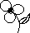 bottle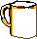 mug
spoon flower

Teaching/Learning aids: Real objects
LESSON THREE
TOPIC: THINGS AT HOME
ACTIVITY: CIRCLE THE SAME PICTURES

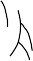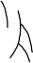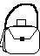
Teaching/Learning aids: Real objects


LESSON FOUR
TOPIC: THINGS AT HOME
ACTIVITY: CIRCLE THE SAME PICTURES
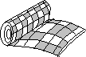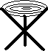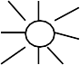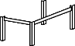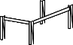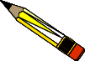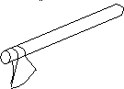
Teaching/Learning aids: Real objects
LESSON FIVE TOPIC:COMPARING SMALL/BIG
ACTIVITY:COLOUR THE SMALLER PICTURE



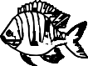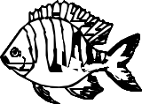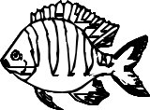

WEEK VII
TOPIC: COMPARING BIG AND SMALL
ACTIVITY: LEARNERS WILL TICk THE SMALL PICTURES ONLY.


Materials to be used: real objects and charts in class.
LESSON TWO
TOPIC: COMPARING BIG/SMALL
ACTIVITY: PUPILS WILL LEARN, TOUCH AND SHADE/ COLOUR THE SMALL PICTURE.

Materials to be used: Real objects

LESSON THREE
TOPIC: COMPARING BIG/SMALL
ACTIVITY: LEARNER WILL IDENTIFY THE BIG PICTURE AND CROSS IT.

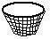

LESSON FOUR TOPIC:COMPARING BIG/SMALL
ACTIVITY:LEARNER WILL UNDERLINE THE BIG PICTURE.
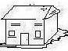


Learning materials:Real objects, chart in class

LESSON FIVE TOPIC:COMPARING BIG/SMALL
ACTIVITY:LEARNERS WILL READ AND DRAW
Draw a big mat Draw a small ball
Materials to be used: real objects, pencils and books
WEEK VIII LESSON ONE
TOPIC:MISSING PART
ACTIVITY:DRAW THE MISSING PART


Teaching/learning aids: Cut outs, jig saws
Lesson two
TOPIC:Missing part
Activity:Draw the missing part
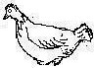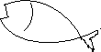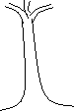
Teaching/learning aids: cut outs, jig saws

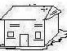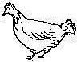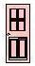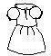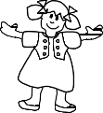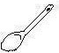LESSON THREE TOPIC:BELONGINGS
ACTIVITY:MATCH TO THE BELONGING

LESSON FOUR TOPIC:BELONGING
ACTIVITY:MATCH TO THE BELONGING

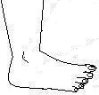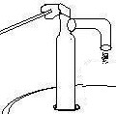

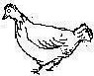

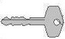

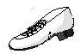

LESSON FIVE TOPIC:BELONGING ACTIVITY:MATCH
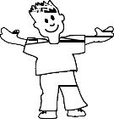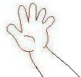

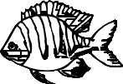



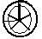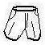
Teaching/learning aids: Real objects, e.g watch, hand, shorts, etc


WEEK IX LESSON ONE
TOPIC:COMMON NOUNS
ACTIVITY:LEARNERS WILL READ THE WORD CORRECTLY AND DRAW THE PICTURES.
tin cup ball cat cow
Materials to be used: charts, flash cards, books and pencils.

LESSON TWO TOPIC:COMMON NOUNS
ACTIVITY:LEARNERS WILL READ THE WORDS CORRECTLY AND TICk THE CORRECT WORD FOR THE PICTURE GIVEN. E.G.
Hat dog tin
hen√ door tea
hut duck tie

Learning materials should be: flash cards, chart in class, books and pencils.

LESSON THREE TOPIC:COMMON NOUNS
ACTIVITY: LEARNERS WILL READ AND CROSS THE CORRECT WORD.
hen ehn neh
odg dog god
LESSON FOUR
TOPIC:COMMON NOUNS/NEW WORDS ACTIVITY:LEARNERS WILL FILL IN THE MISSING LETTER/WORD E.G

b ok r t b g c r

Materials to be used: Chart in the class, books and pencils

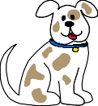


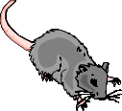

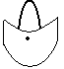

LESSON FIVE
TOPIC:COMMON NOUNS/NEW WORDS ACTIVITY:LEARNERS WILL CONTINUE TO FILL IN THE MISSING LETTER IN A WORD.
Fill in the missing letter.

f sh b y m g pe

Learning materials to be used: Chart in the class, books and pencils.
WEEK X LESSON ONE
TOPIC:COMMON NOUNS
ACTIVITY:LEARNERS WILL CROSS OUT THE DIFFERENT WORD E.G.
Cow cow cat
cup tin cup Teaching/learning aids: Card, charts

LESSON TWO TOPIC:COMMON NOUNS
ACTIVITY:LEARNERS WILL CROSS OUT THE DIFFERENT WORD.
spoon spoon stool
car car can
Teaching/Learning aids: Card/ Charts

LESSON THREE TOPIC:COMMON NOUNS
ACTIVITY:LEARNERS WILL TICk THE CORRECT WORD.
hne nhe hen
eye yee eey
mna nam man
Materials to be used: cards, dominos
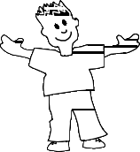
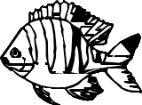


LESSON FOUR TOPIC:COMMON NOUNS
ACTIVITYLEARNERS WILL TICk THE CORRECT WORD
blla allb ball
dog gdo ogd
Teaching learning aids: cards

LESSON FIVE TOPIC:COMMON NOUNS
ACTIVITY:LEARNERS WILL UNDERLINE THE CORRECT WORD.
blla bkoo
ball boko
llab book



